​EXPERIMENT: ANNOTATED PARSE TREE USING C​
​1. AIM​
​To write and execute a C program to construct an annotated parse tree for an​​arithmetic expression and evaluate its final value.​
​2. ALGORITHM:​
​1.​ ​Start the program.​
​2.​ ​Define a structure for the parse tree node.​
​3.​ ​Read an arithmetic expression.​
​4.​ ​Create nodes for numbers and operators.​
​5.​ ​Parse the expression using​​parseT()​​and​​parseE()​​.​​6.​ ​Calculate the value of each node.​
​7.​ ​Display the annotated parse tree.​
​8.​ ​Print the final evaluated value.​
​9.​ ​Stop the program.​
​3.PSEUDO CODE:​
​START​
​Read arithmetic expression​
​Create parse tree nodes​
​Parse numbers using parseT()​
​Parse additions using parseE()​
​Calculate node values​
​Display annotated parse tree​
​Print final evaluated value​
​STOP​
​C PROGRAM:​
​#include <stdio.h>​
​#include <stdlib.h>​
​#include <ctype.h>​
​#include <string.h>​
​typedef struct Node {​
​char name[10];​

​int val;​
​struct Node *left, *right;​
​} Node;​
​Node* createNode(char *name, int val, Node *l, Node *r)​​{​
​Node *n = malloc(sizeof(Node));​
​strcpy(n->name, name);​
​n->val = val;​
​n->left = l;​
​n->right = r;​
​return n;​
​}​
​Node* parseT(char **s)​
​{​
​int num = 0;​
​while (isdigit((unsigned char)**s)) {​
​num = num * 10 + (**s - '0');​
​(*s)++;​
​}​
​return createNode("T", num,​
​createNode("num", num, NULL, NULL), NULL);​​}​
​Node* parseE(char **s)​
​{​
​Node *left = parseT(s);​
​while (**s == '+') {​
​(*s)++;​
​Node *right = parseT(s);​
​left = createNode("E",​
​left->val + right->val, left, right);​
​}​
​return left;​
​}​
​void display(Node *root, int level)​
​{​

​if (root == NULL) return;​
​for (int i = 0; i < level; i++)​
​printf(" ");​
​printf("%s = %d\n", root->name, root->val);​
​display(root->left, level + 1);​
​display(root->right, level + 1);​
​}​
​int main()​
​{​
​char expression[100];​
​char *s;​
​printf("Enter arithmetic expression: ");​
​fgets(expression, sizeof(expression), stdin);​
​s = expression;​
​Node *root = parseE(&s);​
​printf("\nAnnotated Parse Tree:\n");​
​display(root, 0);​
​printf("\nFinal Evaluated Value = %d\n", root->val);​ ​return 0;​
​}​
​INPUT:​
​Enter arithmetic expression: 10+20+30W​

​0UTPUT:​
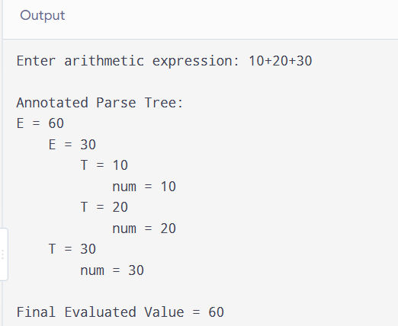
​RESULT:​
​Thus, the C program was successfully executed to construct an annotated parse tree​
​and evaluate the given arithmetic expression.​

